**Full Stack Development with MERN**

**Frontend Development Report**

| Date | 11th July, 2024 |
| --- | --- |
| Team ID | SWTID1720019605 |
| Project Name | Grocery-web app |
| Maximum Marks |  |

**Project Title: Farmzi**

Date: 11/07/24

Prepared by: SWTID1720019605

**Objective**

The objective of this report is to document the frontend development progress and key aspects of the user interface implementation for the [Your Project Title] project.

**Technologies Used**

* **Frontend Framework:** React.js
* **UI Framework/Libraries:** React-Toastify
* **State Management:** Context API
* **API Libraries:** Axios
* **Project Structure**

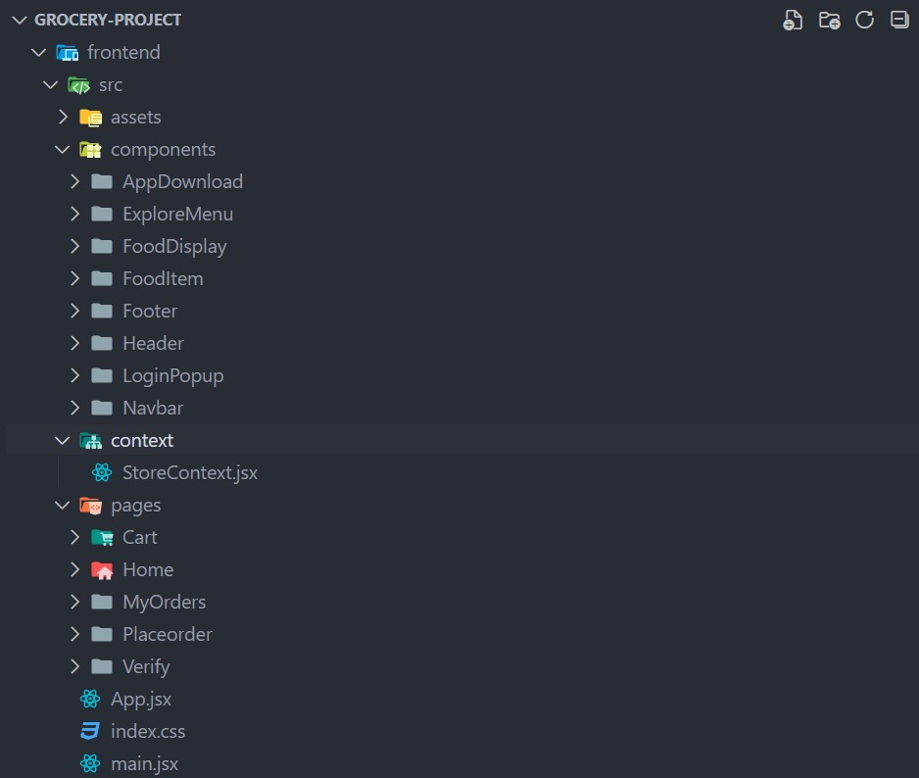

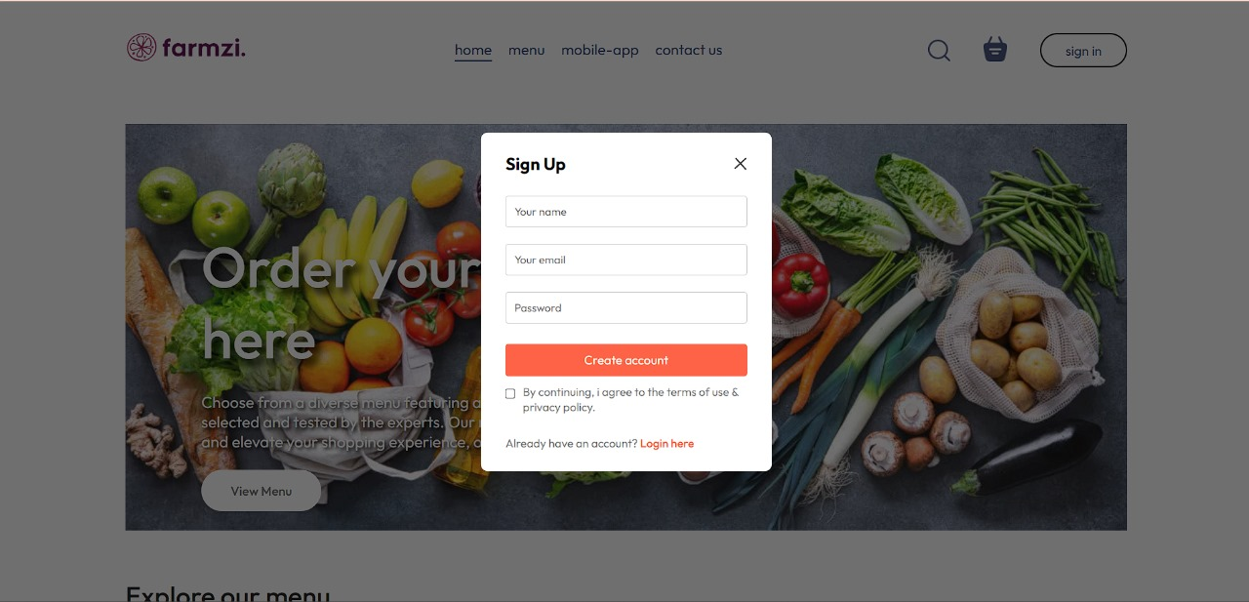

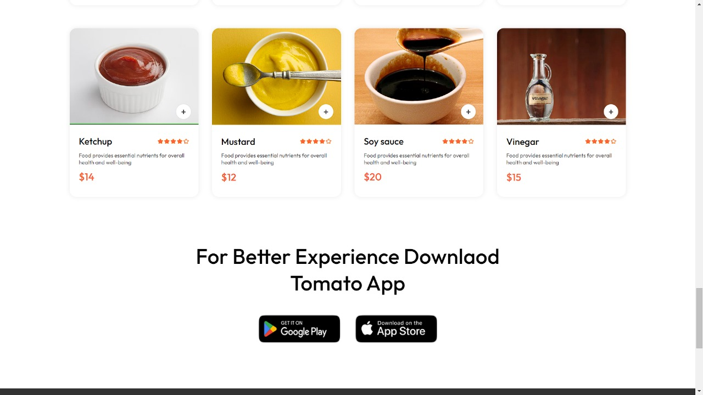

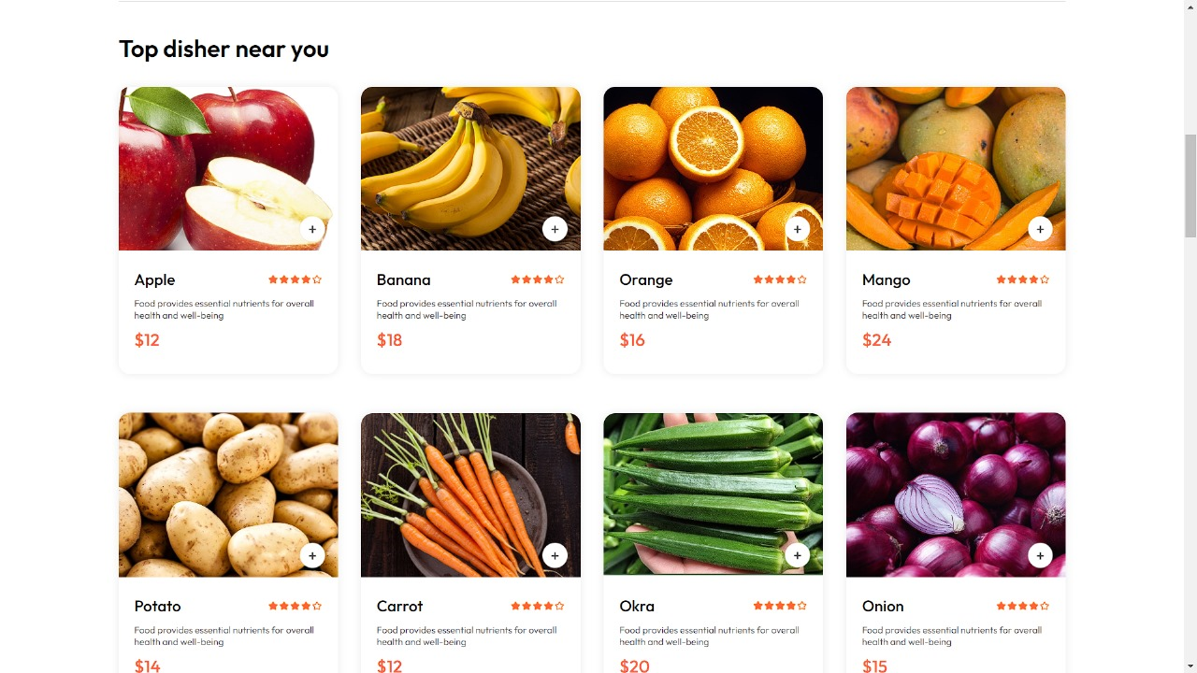

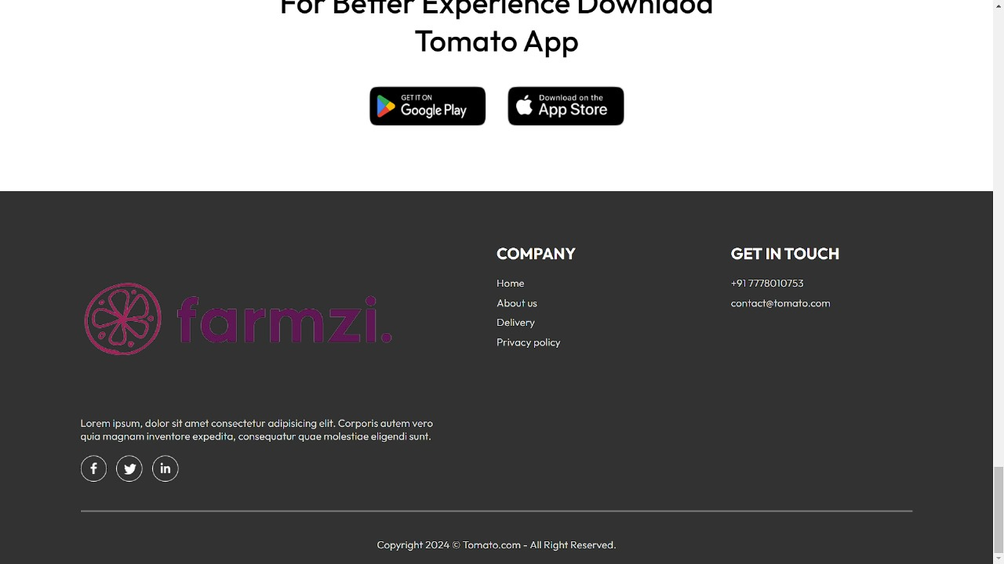

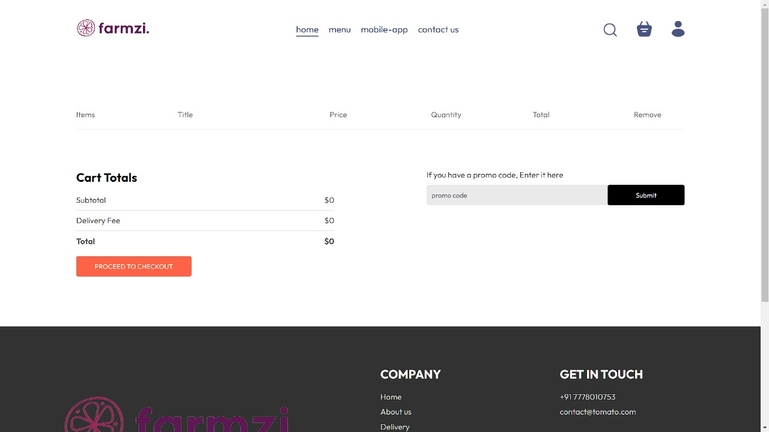

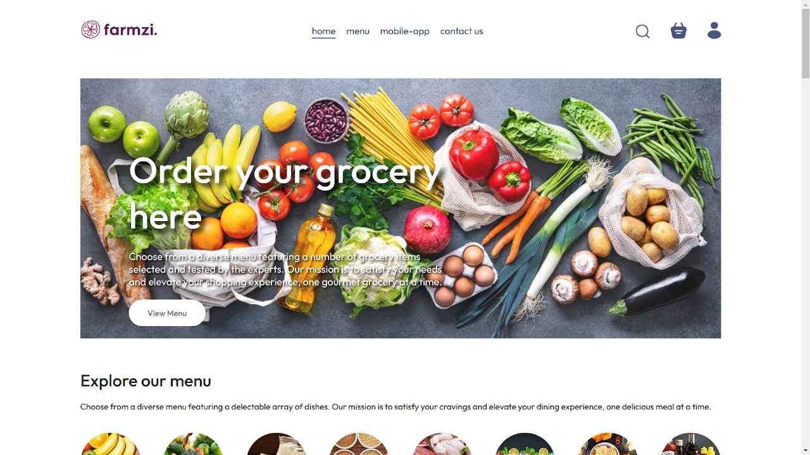

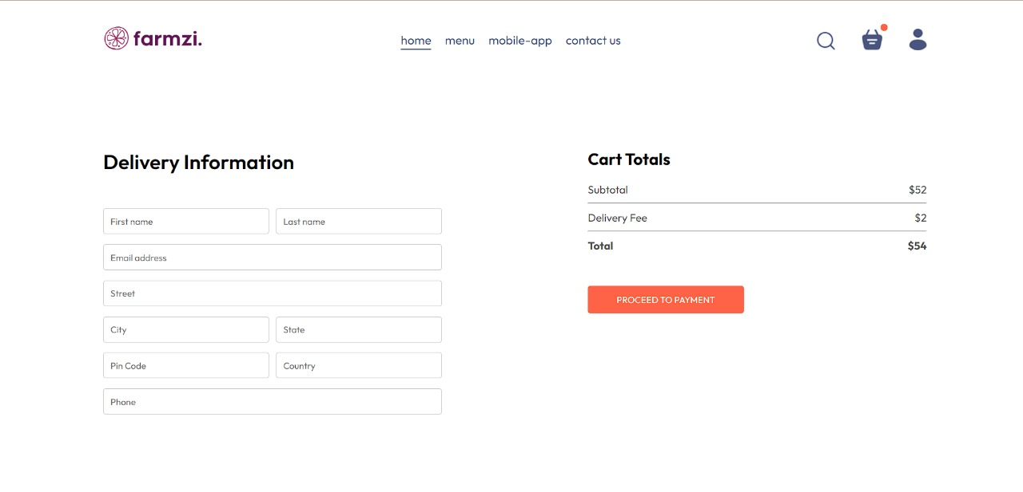

**Key Components**

1. **App.js**
   * Responsible for routing and main application layout.
2. **/components**
   * AppDownload
   * ExploreMenu
   * FoodDisplay
   * FoodItem
   * Footer
   * Header
   * LoginPopup
   * Navbar
3. **/pages**
   * Cart
   * Home
   * MyOrders
   * Verify

**Routing**

Routing is managed using React Router. Here are the main routes:

* **/**- Landing page of the application.
* **/cart** - Display the items in the cart
* **/verify** - Verification
* **/myorders** - orders

**State Management**

State management is achieved using Context API.

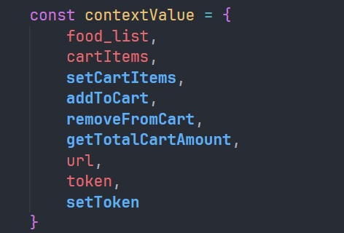

**Integration with Backend**

The frontend communicates with the backend APIs hosted on [backend URL]. Key endpoints include:

### Food API Endpoints

1. **GET /api/food: Retrieve details of a specific food item.**

### User API Endpoints

**2. POST /api/user/: Register or login a new user.**

### Cart API Endpoints

1. **POST /api/cart: Controls cart functionalities**

### Order API Endpoints

1. **POST /api/order/: Controls order functionalities**

**User Interface (UI) Design**

* The UI design follows a Consistency
* Implemented using React.js

**Third-Party Integrations (If any)**

* ReactRouterDOM
* React Toastify
* AXIOS